Mbonu Somtochukwu

CYBER SECURITY

BHU/22/04/09/0027

CYB202

PROJECT 2

Project Two

Objective

Use Windows Operating Systems basic tools to enhance the defence PCs and data

Task

You have been provided a manual on Windows Operating System Basics, study the manual and do the following:

1. Navigate the windows OS encryption tool to encrypt your pen drive (flash drive). Show all steps of this process with screenshot. Clearly show the encryption key generated.

CAUTION: DO NOT PERFORM THIS PROCESS ON YOUR HARDRIVE

1. Enable Windows Defender on your system to support continuous scan for malware (malicious software), viruses, and security threats and provide real-time protection for your system. Show all steps with screen shots.

Answers:

1.

For this scenario we will be using ARK(D:)

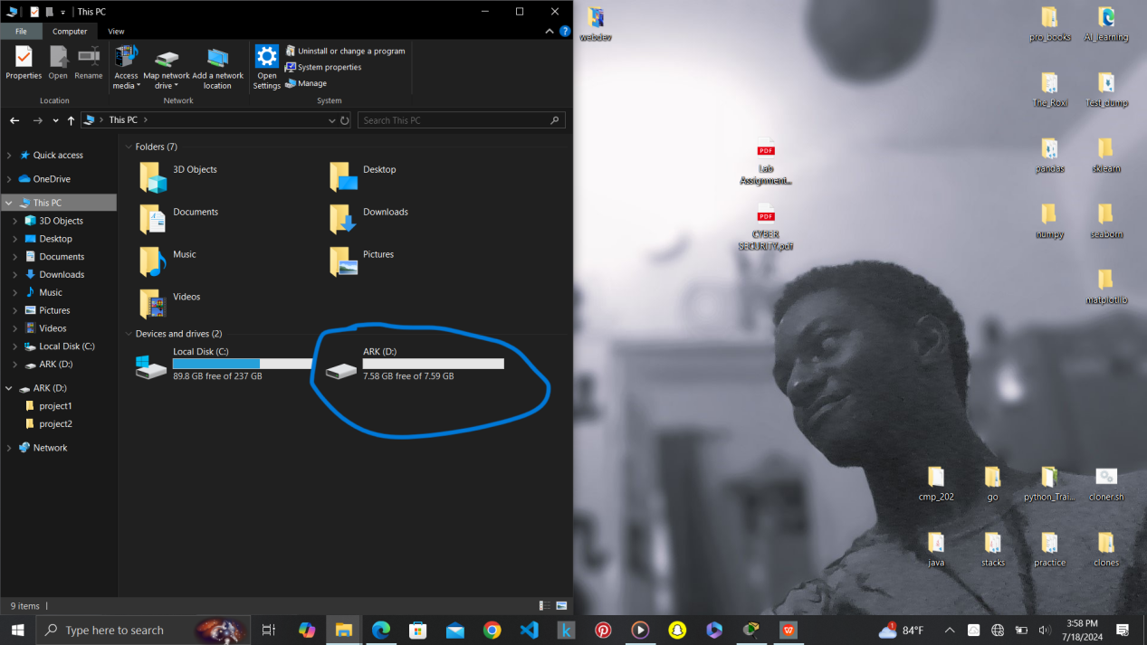

- WE locate and open our Bitlocker manager.

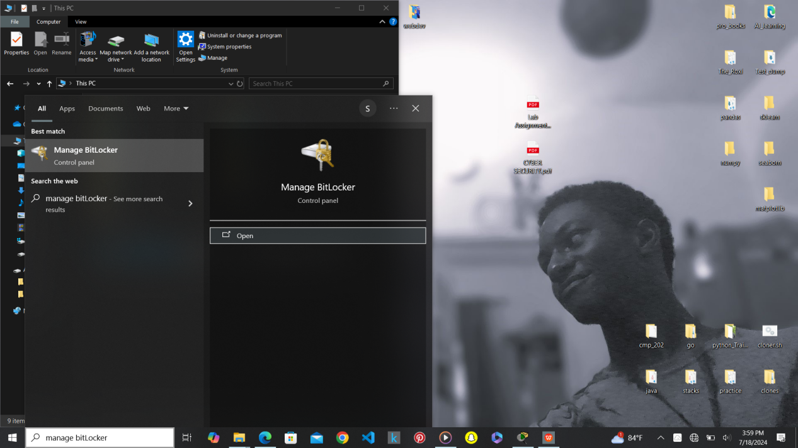

- Select the “Storage Device” we will use, in this case it will be ARK(D:)

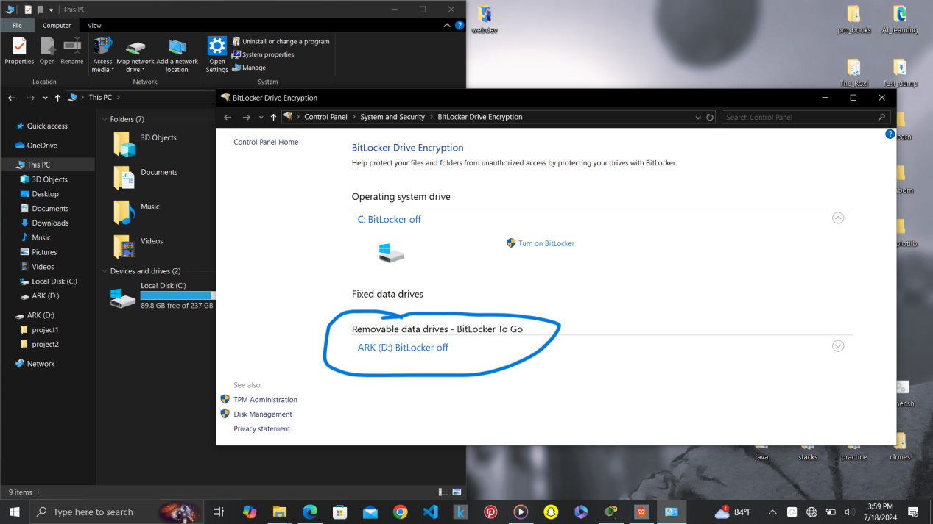

- Turn on the Bitlocker

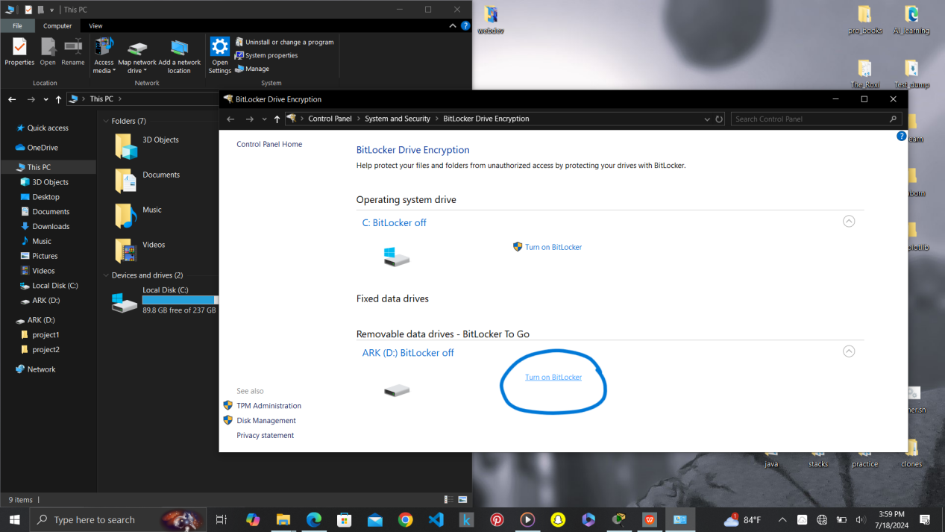

-Select “Use a password to unlock the drive” and input a Password.

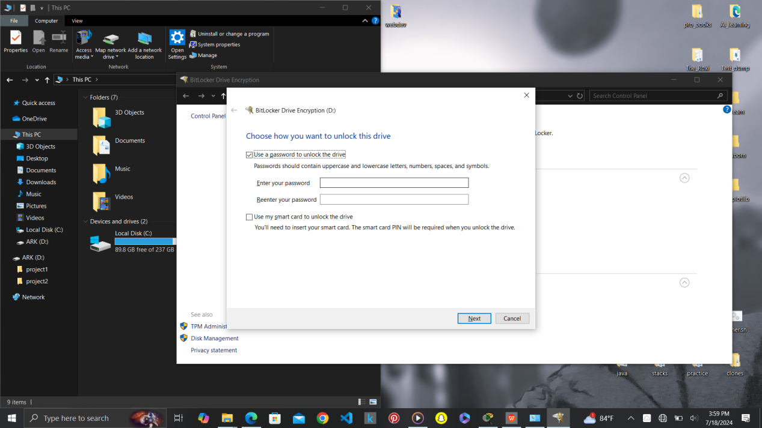

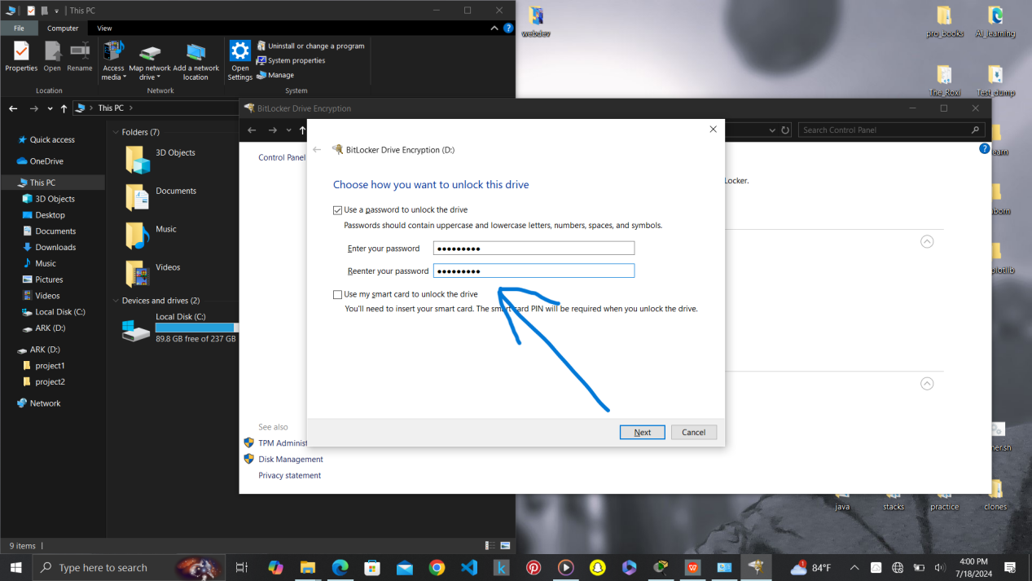

- Set a backup recovery key.

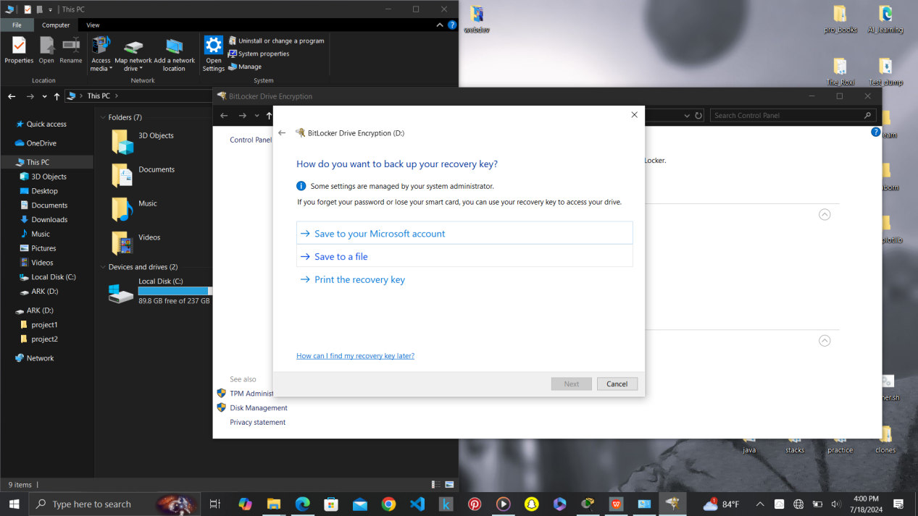

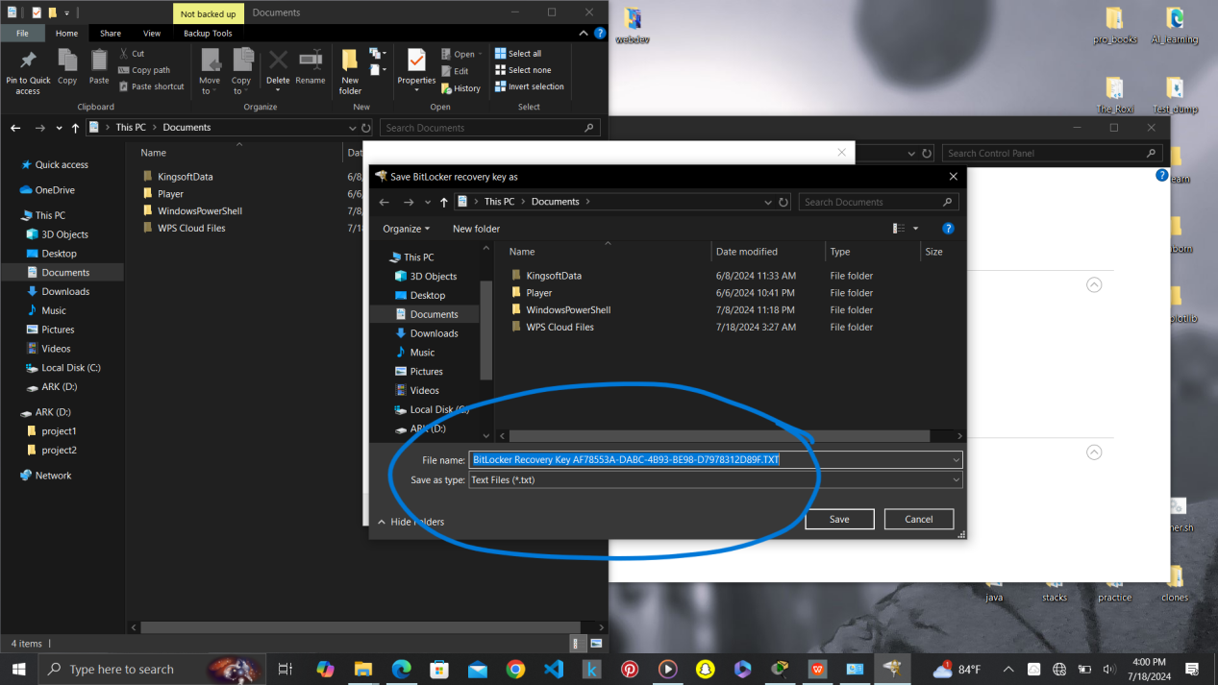

- Set the amount of the Drive you want to encrypt. In this case the whole drive.

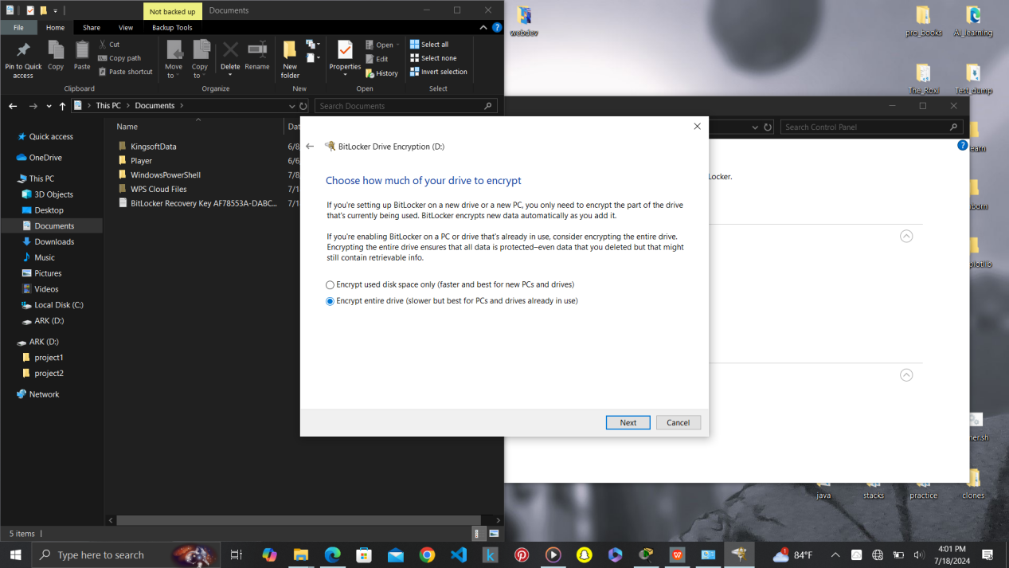

- Pick an “ Encryption Mode”

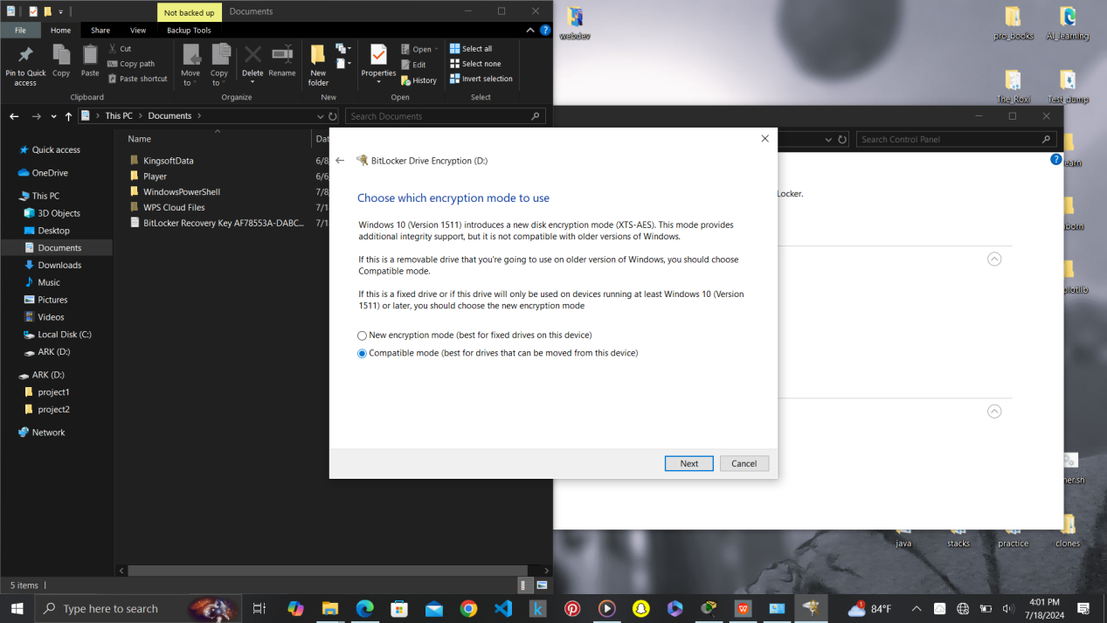

- Then you encrypt the Drive

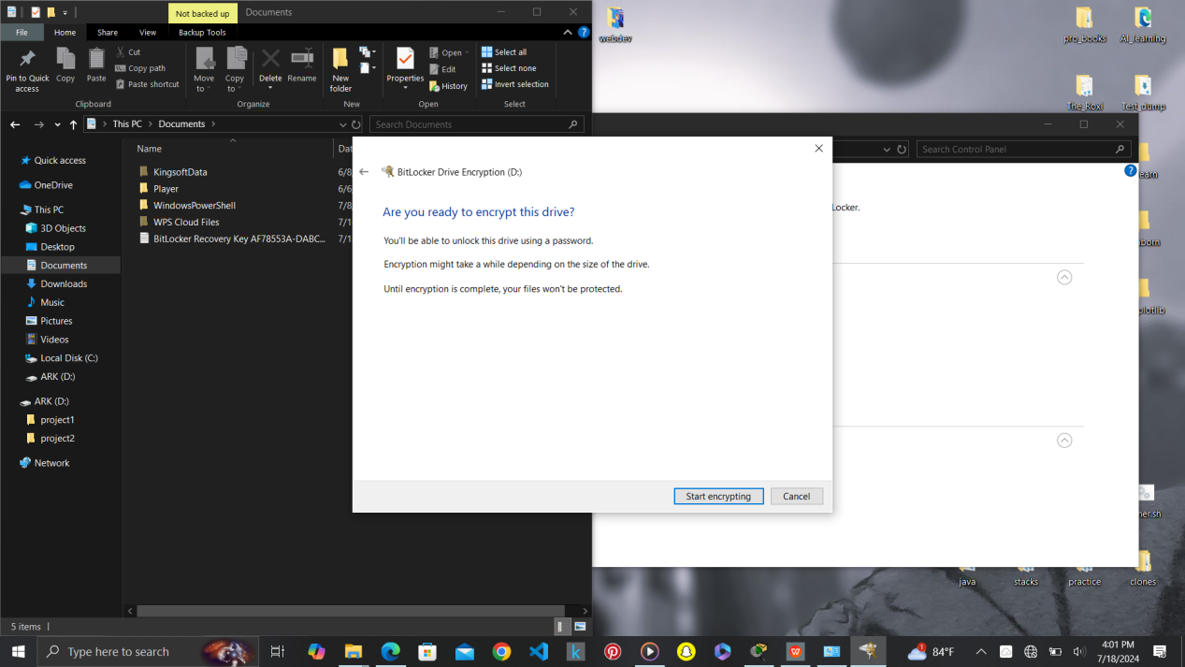

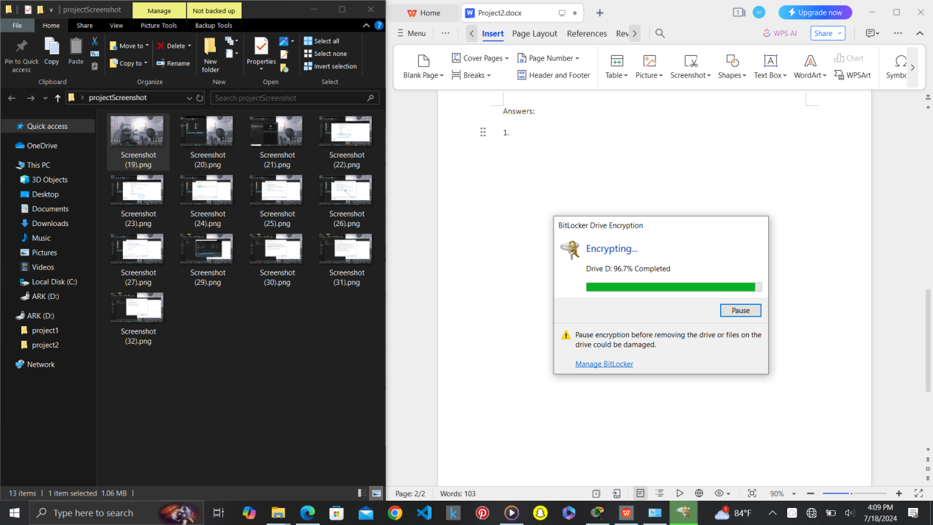

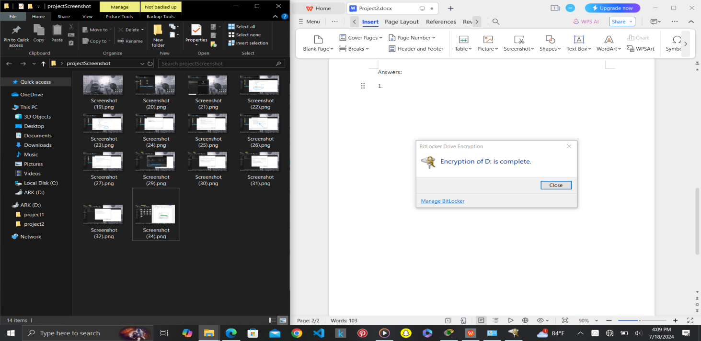

- finally you have encrypted the Drive.

1. Locate and open windows security  
   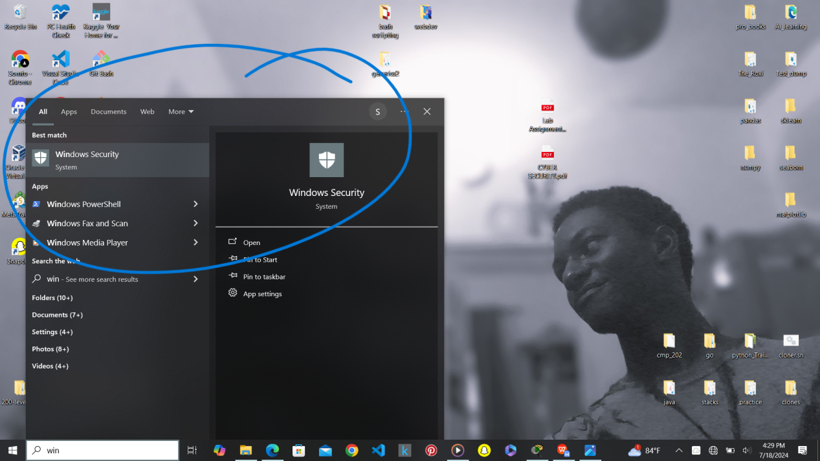

- Turn on “Virus & threat protection”

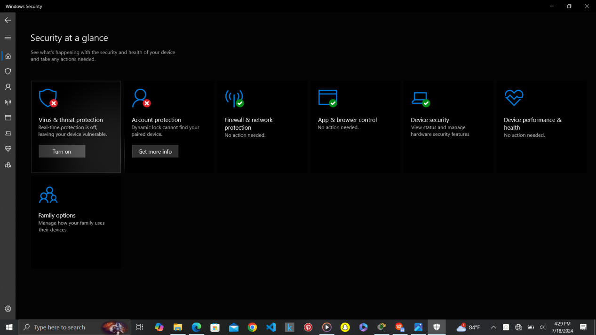

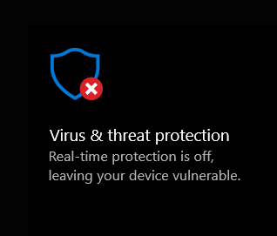

- Tap “Virus & threat protection” , locate the “ Manage settings” and tap on it.

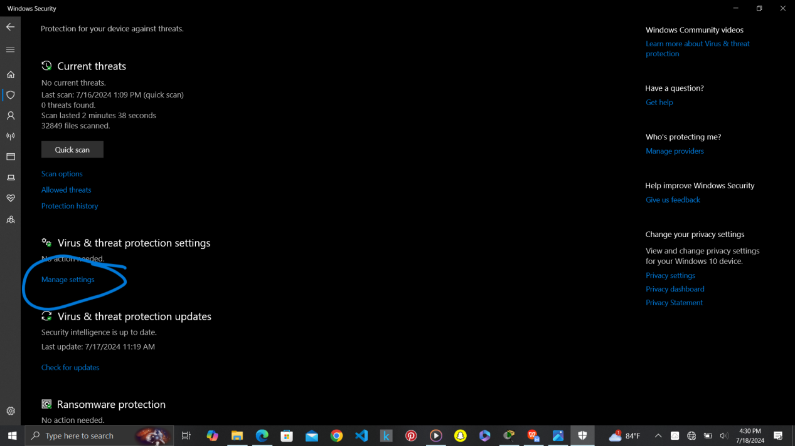

_ Turn on the “Real-Time” protection.   
  
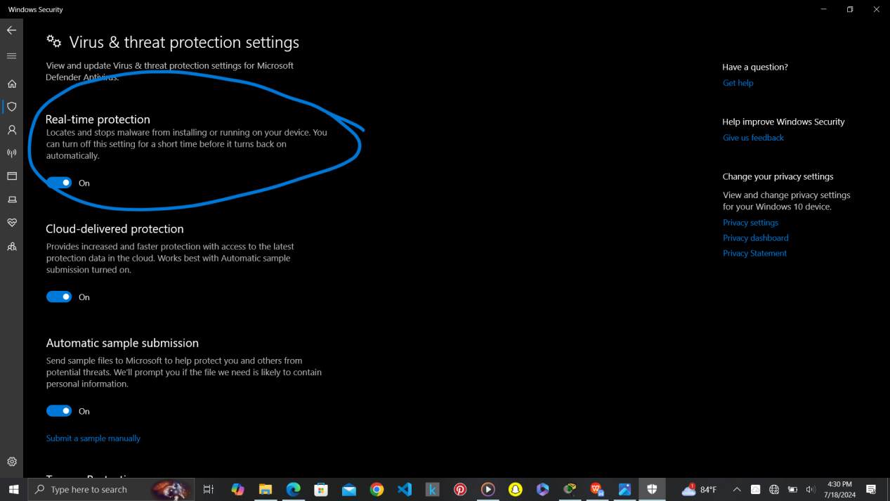

Windows protection is now complete.